SUMMER INTERNSHIP B.TECH 3 YEAR PASSING STUDENTS
Encryption and Decryption text Tool
Summer Internship Report Submitted to

Sharda University



In partial fulfilment of the requirements of the award of the
Degree of Bachelor of Technology
in
Computer Science Engineering

by
Nikhil raj
Under the guidance of
Dr. Rosey jadon
Assistant professor

Department of Computer Science Engineering
School of Engineering & Technology Sharda University
Greater Noida
[july, 2025]

DECLARATION OF THE STUDENT
We hereby declare that the project entitled is an outcome of our own efforts under the guidance of Dr.Rosey jadon . The project is submitted to the Sharda University for the partial fulfilmentof the Bachelor of Technology Examination 2025-26.
We also declare that this project report has not been previously submitted to any other university.

Nikhil raj (2201010470)

CERTIFICATE

This is to inform that Nikhil raj of Sharda University has successfully completed the project work titled Encryption and Decryption Text tool in partial fulfilment of the Bachelor of TechnologyExamination 2025-26
This project report is the record of authentic work carried out by them during the period from MAY 2025 to July 2024.

Student Signature

Nikhil raj(2201010470)

Faculty’s signature HoD’s signature

Dr.Rosey jadon Dr.Sudeep Varshney

Assistant professor HEAD OF DEPARTMENT
Computer Science & Engineering

ABSTRACT
In Today’s era of growing digital communication and data transmission, safeguarding sensitive information is crucial. This project focuses on the development of an encryption and decryption text tool, which ensures secure communication by converting plaintext into ciphertext using a variety of encryption algorithms, and subsequently decrypting it back to its original form when necessary. The tool supports multiple algorithms such as Caesar Cipher, Advanced Encryption Standard (AES), and Rivest-Shamir-Adleman (RSA), offering users flexibility in their security needs. Implemented in Python, the tool provides both a command-line interface (CLI) and a graphical user interface (GUI), allowing users to easily input text, select encryption methods, generate or input secure keys, and view the encrypted/decrypted text. The system is designed with a focus on data confidentiality and user-friendliness. Through rigorous testing, the tool has demonstrated its capability to securely handle various encryption processes. Future enhancements may include the integration of additional algorithms and advanced security measures, positioning the tool as a vital asset for both individual and organizational use in secure communications.

ACKNOWLEDGEMENT

I would like to express my deepest appreciation to all those who provided me the possibility to complete this report. Apart from the efforts of myself, the success of any project depends largely on the encouragement and guidelines of many others. We take this opportunity to express my gratitude to the people who have been instrumental in the successful completion of this project. We would like to show my greatest appreciation to DR.ROSEY JADON. We can’t saythank you enough for her/his tremendous support and help. We feel motivated and encouraged every time we attend her meeting. Without her encouragement and guidance this project would not have materialized. The guidance and support received from all the members who contributed and who are contributing to this project, was vital for the success of the project. We are grateful for their constantsupport and help. Besides, we would like to thank the authority of Sharda University for providing us with a good environment and facilities to complete this project. Finally, an honourable mention goes to our families and friends for their understandings and supports on us in completing this project. Without helpsof the particular that mentioned above, we would face many difficulties while doing this.

LIST OF FIGURES

Sr. No. | Figure Number | Page number
1 | Figure 1 | 14
2 | Figure 2 | 16-17
3 | Figure 3 | 18
4 | Figure 4 | 18

TABLE OF CONTENTS

Sr. No. | Contents | Page No.
 | Title Page | I
 | Declaration of the Student | Ii
 | Certificate of the Guide | Iii
 | Abstract | Iv
 | Acknowledgement | V
1 | INTRODUCTION  - Problem Definition  - Hardware Specification  - Software Specification  - Motivation  - Objectives  - Contributions  - Summary | 8-11
2 | LITERATURE SURVEY  - Related Work Summary | 12
3 | DESIGN AND IMPLEMENTATION  - Methodology  - Design  - Implementation  Summary | 13-17
4 | RESULT AND DISCUSSIONS  - Results  - Discussion Summary | 18
5 | CONCLUSION  - Conclusion  - Limitations  - Future Scope Summary | 19-20
6 | REFERENCES | 21

INTRODUCTION

PROBLEM DEFINATION
In today's interconnected world, a significant amount of sensitive data is transmitted over the internet, ranging from personal information to financial and business data. With the increasing risk of data breaches and unauthorized access in digital communication, there is a crucial need to protect sensitive information. The challenge is to secure data through encryption, Converting it into unreadable text(cipher) that can only be decrypted by authorized User. This project aims to address these issues by developing a user-friendly tool that encrypts and decrypts text using python, Crypto Libraries, various algorithms, ensuring data confidentiality and secure key management.

HARDWARE SPECIFICATION
- Windows 7/8/10/11
- 8GB Ram
- 256GB SSD
- X64 based processor

SOFTWARE SPECIFICATION
- Python version (Python 3.12.4)

- Libraries and Dependencies:

  - PyCryptodome: A Python library for implementing cryptographic algorithms like AES.

  - tkinter: For building a simple GUI (user graphical interface).

  - argparse: For command-line interface (CLI) support to allow encryption and decryption via terminal/command prompt.

  - rsa: Python package for generating RSA keys and performing encryption/decryption.

- Editor: VS CODE Studio.

MOTIVATION
Data security and privacy are critical in the current digital era. Since personal, financial, and business data is shared online more often, there is a greater chance of data breaches, hacks, and unauthorised access. As a result, it becomes imperative that people and organisations safeguard confidential information to prevent it from getting into the wrong hands.

- Growing Threat of Cybercrime: With the increase in hacking, phishing attacks, and data breaches, ensuring the security of digital communication is more important than ever. A strong method for reducing these threat is encryption, which protects data from unauthorized access.
- Data Confidentiality: Encryption helps safeguard sensitive data, whether it is being stored or transported, by ensuring that only authorised parties possessing the right decryption key can view the original content.

- User-Friendly Security Solutions: The majority of the encryption solutions on the market today might be complicated and challenging for non-technical consumers to utilise. There is obviously a need for an easy- to-use program that makes it possible for anyone to safely encrypt and decrypt text, regardless of technical proficiency.
- Compliance with Security Standards: Strict laws (such as GDPR and HIPAA) requiring the use of encryption for sensitive data bind a number of businesses, including healthcare, finance, and government. The goal of this project is to provide a user-friendly solution that complies with these legal specifications.

OBJECTIVES
The objectives of the encryption and decryption text tool project are:

- Provide Data Security: Create a program that encrypts text to prevent unauthorised people from accessing it, protecting the privacy and security of sensitive data.

- User-Friendly Interface: Design a graphical user interface (GUI) that is simple to use and intuitive so that even those with less technical experience may safely encrypt and decrypt text.
- Support for Robust Encryption Algorithm: To provide dependable and robust encryption for the data, use secure encryption algorithms like Fernet (symmetric encryption) from the cryptography library.

- Seamless Encryption and Decryption: Make sure that the same key may be used for both procedures by enabling users to quickly and simply encrypt plaintext and decrypt ciphertext.

- Effective Key Management: Create and maintain encryption keys safely, making sure that the encrypted text can only be decrypted by authorised users who possess the right key.

- background Image Handling: Include background images to improve the tool's aesthetic appeal. You can centre and scale the images according to the size of the window. This makes for a more pleasing user experience.

CONTRIBUTIONS
- Simplified Encryption for Non-Technical Users:The project provides an intuitive graphical user interface (GUI) using Tkinter, allowing users with little to no technical background to securely encrypt and decrypt text without complex command-line operations.
- Implementation of Secure Encryption Algorithms:The tool uses the Fernet encryption from the cryptography library, which offers strong encryption based on symmetric key cryptography. This ensures the confidentiality of sensitive data and meets modern security standards.
- Real-Time Text Encryption and Decryption:Users can easily input plain text for encryption and quickly retrieve the encrypted text or provide encrypted text for immediate decryption. This seamless workflow supports real-time data protection and retrieval.
- Visual Enhancement through GUI with Background Images:The tool integrates a feature for handling background images using the Pillow library, providing a visually appealing interface that adapts dynamically to window resizing, making the user experience more engaging and pleasant.

SUMMARY
The encryption and decryption text tool is designed to provide a secure, he tool guarantees that plaintext can be safely transformed into ciphertext and vice versa by utilising contemporary cryptographic techniques, particularly the Fernet encryption algorithm from the cryptography library.

- Introduction to Cryptography: Convert the plain text to cipher text by encryption and cipher to plain text by decryption.

- Symmetric and Asymmetric Encryption: Both symmetric (AES, DES) and asymmetric (RSA) encryption are thoroughly explained. Asymmetric encryption uses two keys— public and private—for secure communication, whereas symmetric encryption uses a single key for encryption and decoding.
- Python Encryption Libraries: PyCryptodome and other well-known Python cryptography libraries are used. use these libraries to implement various encryption algorithms efficiently.

- Creating the Encryption Tool: Creating a text encryption and decryption tool that runs on Python. This covers key management, processing user input, and selecting encryption techniques.

- Code Implementation: Python code used to implement both symmetric and asymmetric encryption techniques, such as AES and RSA.

LITERATURE SURVEY
- History of Cryptography: Since ancient times, cryptography has been crucial for secure communication. Its earliest examples include the Caesar Cypher, which shifts letters in a message by a predetermined amount, and the Enigma Machine, which was used to encrypt and decode messages during World War II. On the other hand, modern cryptography has changed dramatically, concentrating on employing sophisticated mathematical methods to secure digital communications. The Caesar Cypher, one of the first encryption techniques, was a straightforward substitution cypher that Julius Caesar employed to safeguard military communications. Despite being straightforward, it illustrated the essential idea behind message encryption as a means of safeguarding confidential data[1].

Symmetric vs Asymmetric Encryption:
  - Symmetric Encryption: In symmetric encryption, the same key is used for both encryption and decryption. This method is fast and efficient for encrypting large datasets but poses a challenge in securely sharing the key.
AES is a popular symmetric encryption standard that was created by Vincent Rijmen and Joan Daemen and was approved by the US government in 2001. With key lengths of 128, 192, or 256 bits, AES runs on fixed block sizes of 128 bits. Sensitive data encryption frequently uses AES due to its great efficiency and security.
  - Asymmetric Encryption: In asymmetric encryption, a public key is used for encryption, and a corresponding private key is used for decryption. RSA (Rivest–Shamir–Adleman) is one of the most commonly used asymmetric encryption algorithms, providing strong security but at a higher computational cost compared to symmetric encryption.

Cryptography Libraries for Python:
  - PyCryptodome: An effective cryptography library that offers hashing functions and a number of encryption methods, including RSA and AES. Strong security is a requirement for many Python projects, but PyCryptodome can be difficult for novices to install [2].
  - Cryptography: The Fernet encryption algorithm is provided by the cryptography package, which also offers a streamlined API for data encryption and decryption with great security. Fernet was selected for this project due to its ease of use and compatibility with contemporary cryptographic standards [3].

User Interface Design for Security Tools:
Tkinter: Tkinter is the default Python GUI package, and it offers a user-friendly environment for creating basic interactive programs. It is the perfect fit for this project since it provides the freedom to design security tools that are easy to use [4].

DESIGN AND IMPLEMENTATION

METHODOLOGY

The methodology to design, develop, and implement the encryption and decryption text tool in Python. It also outlines the process of testing and validating the tool to ensure functionality, security, and usability. The following steps outline the development process:

Requirement Analysis:
  - Objective: Specify the functional needs for the tool, including key generation, text encryption, decryption, and an intuitive graphical user interface (GUI).
  - Output: A comprehensive comprehension of the tool's objectives, which include cross- platform interoperability, secure encryption and decryption, and user-friendliness.
- Technology Selection:
  - Programming Language: Python was selected for its ease of use, large community support, and availability of robust cryptographic libraries.

  - GUI Framework: Tkinter was chosen for its simplicity and ability to create an intuitive graphical interface. It allows the creation of user-friendly buttons, labels, and input fields for text encryption and decryption.

  - Cryptography Library: The cryptography package was selected for implementing the encryption mechanism due to its security, simplicity, and support for the Fernet encryption algorithm, which provides both confidentiality and integrity.

Design of the Graphical User Interface (GUI):
  - Objective: Create a user interface that is simple to understand and use so that users can input text, execute encryption and decryption, and see the outcomes with ease.
  - Process:
Tkinter Layout: Tkinter was used to design the GUI, which included:
    - Input fields for the user to enter plaintext for encryption and ciphertext for decryption.
    - Buttons for triggering encryption and decryption functions.
    - Output areas to display the encrypted or decrypted text.
  - Background Image: To enhance the visual appearance of the tool, an image is loaded and resized dynamically using the Pillow library, adjusting to window size changes.

Implementation of Encryption and Decryption Functions: Encryption:
  - Process: When the user enters text in the input field and clicks the "Encrypt" button, the tool uses the Fernet encryption algorithm to convert plaintext into ciphertext. The encrypted text is displayed in the decryption field.

Algorithm:
    - The Fernet algorithm generates a symmetric key for encryption and decryption.
    - The plaintext is encoded to bytes and encrypted using this key.
    - The result is then decoded to a string and displayed in the GUI.

Decryption:
  - Process: When the user enters the encrypted text and clicks the "Decrypt" button, the tool attempts to decrypt the ciphertext back into plaintext.
  - Algorithm:
    - The encrypted text is decoded from string to bytes and decrypted using the same symmetric key.
    - The resulting plaintext is then displayed in the decryption field.

FLOWCHART:
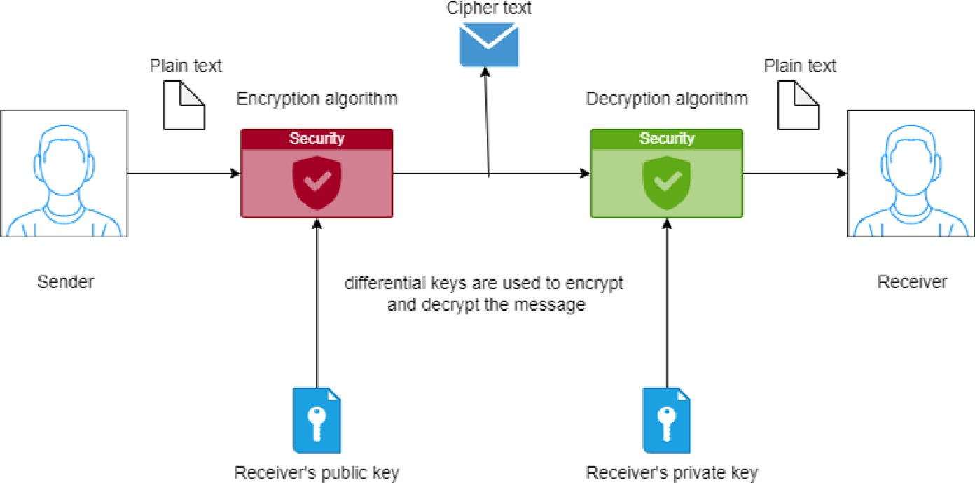

Figure 1

Key Management:
  - Key Generation: The Fernet.generate_key() method creates a symmetric key that is used for encryption and decryption and is safely kept.
  - Key Storage: At the moment, the tool creates and keeps the key inside the session. Future iterations of the software can improve key management by including safe key reuse techniques for external storage.

Testing and Debugging:
  - Unit Testing: Individual functions for encryption and decryption were tested with various inputs, including valid and invalid text, to ensure correct functionality.
  - GUI Testing: The Tkinter interface was tested for usability, ensuring that buttons, input fields, and dynamic image resizing worked as intended on different platforms (Windows, macOS, Linux).

Deployment:
  - The final tool was packaged and made executable on multiple platforms (Windows, macOS, and Linux), ensuring ease of installation and use.
  - Dependencies: Instructions were provided for installing the necessary libraries (cryptography and Pillow) via Python’s package manager pip.

DESIGN
The encryption and decryption tool is designed with two key components: a user-friendly GUI and a secure encryption backend.
- Functional Design:
  - Encryption: Uses the Fernet encryption algorithm to securely convert plaintext to ciphertext.
  - Decryption: Reverses the process, converting ciphertext back to plaintext.
  - Key Management: A symmetric key is generated for encryption/decryption during each session.
- User Interface (UI) Design:
  - Tkinter GUI: Easy-to-use interface with input fields, buttons for encryption and decryption, and a dynamic background image.
  - Text Input/Output: Fields to input plaintext and display encrypted/decrypted text.
  - Buttons: Clear and distinct buttons for "Encrypt" and "Decrypt" actions.
- Aesthetic and Responsive Design:
  - Color Scheme: Black background with green and blue text for a sleek look.
  - Background Image: Resizes dynamically to fit the window for visual appeal.

CODE IMPLEMENTATION:

Figure 2
import tkinter as tk
from tkinter import messagebox
from cryptography.fernet import Fernet from PIL import Image, ImageTk

# Generate a key for encryption and decryption
# You must use this key for both encryption and decryption key = Fernet.generate_key()
cipher_suite = Fernet(key)

# Function to encrypt the text def encrypt_text():
plain_text = entry_encrypt.get() if plain_text:
encrypted_text = cipher_suite.encrypt(plain_text.encode()).decode() entry_decrypt.set(encrypted_text)
else:
messagebox.showwarning("Input Error", "Please enter text to encrypt")

# Function to decrypt the text def decrypt_text():
encrypted_text = entry_decrypt.get() if encrypted_text:
try:
decrypted_text = cipher_suite.decrypt(encrypted_text.encode()).decode()
entry_decrypt.set(decrypted_text) except:
messagebox.showerror("Decryption Error", "Invalid encrypted text")
else:
messagebox.showwarning("Input Error", "Please enter text to decrypt")

# Resize the background image to fit the window size while maintaining aspect ratio
def resize_image(event): new_width = event.width new_height = event.height # Maintain aspect ratio
image = original_image.copy() image.thumbnail((new_width, new_height), Image.ANTIALIAS) # Center the image
width, height = image.size x = (new_width - width) // 2
y = (new_height - height) // 2 background_image = ImageTk.PhotoImage(image)
background_label.config(image=background_image) background_label.image = background_image background_label.place(x=x, y=y, anchor='nw')

# Create the main window

root = tk.Tk()
root.title("Text Encryptor/Decryptor") root.geometry("600x400")

# Load the background image original_image = Image.open("hacker.png")
background_image = ImageTk.PhotoImage(original_image)

# Set the background label with the image background_label = tk.Label(root, image=background_image) background_label.place(relwidth=1, relheight=1) background_label.bind('<Configure>', resize_image)

# Create StringVars to hold the input/output text entry_encrypt = tk.StringVar()
entry_decrypt = tk.StringVar()

# Create and place the widgets with styling
label_encrypt = tk.Label(root, text="Enter text to encrypt/decrypt:", font=("Helvetica", 16), bg="black", fg="lime") label_encrypt.pack(pady=10)

entry_encrypt_field = tk.Entry(root, textvariable=entry_encrypt, width=60, font=("Helvetica", 14))
entry_encrypt_field.pack(pady=5)

encrypt_button = tk.Button(root, text="Encrypt", command=encrypt_text, bg="lightblue", fg="black", font=("Helvetica", 14), width=12) encrypt_button.pack(pady=10)

label_decrypt = tk.Label(root, text="click to decrypt the text:", font=("Helvetica", 16), bg="black", fg="lime") label_decrypt.pack(pady=10)

entry_decrypt_field = tk.Entry(root, textvariable=entry_decrypt, width=60, font=("Helvetica", 14))
entry_decrypt_field.pack(pady=5)

decrypt_button = tk.Button(root, text="Decrypt", command=decrypt_text, bg="lightgreen", fg="black", font=("Helvetica", 14), width=12) decrypt_button.pack(pady=10)

# Start the GUI event loop root.mainloop()

RESULT
Figure 3
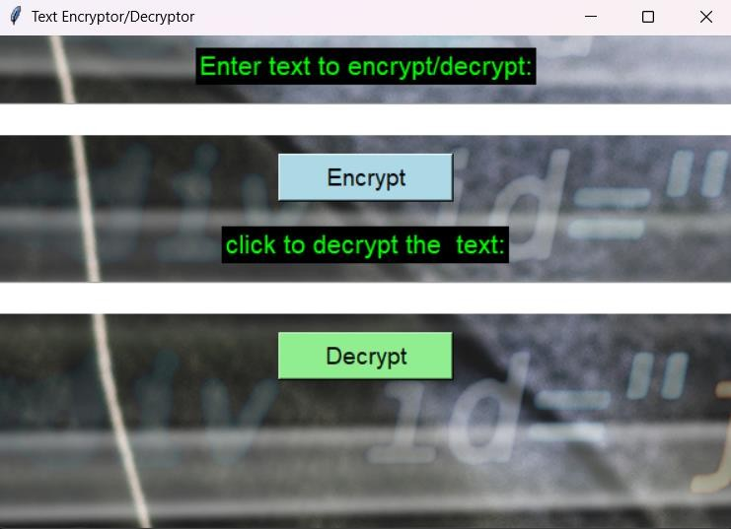
Figure 4
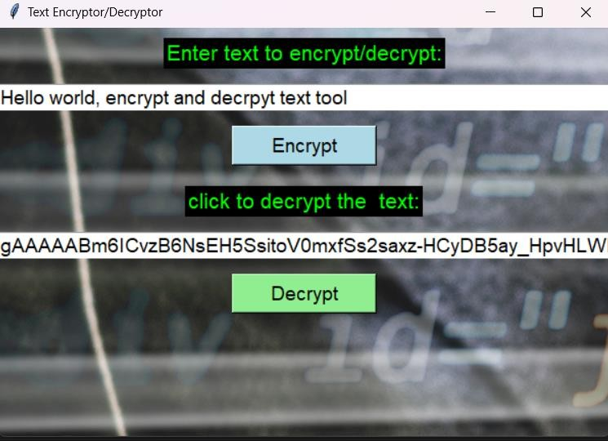

CONCLUSION
The text tool for encryption and decryption offers a simple, safe way to protecting sensitive text documents. Confidentiality is guaranteed by the use of Fernet encryption, and non-technical users can easily navigate the procedure thanks to the user-friendly Tkinter interface. Although it strikes a good mix between security and usability, the program still has potential for improvements in the future, such as key management and asymmetric encryption. All things considered, it's a useful and trustworthy tool for regular text encryption and decryption requirements.

LIMITATION

- Session-Based Keys: Encryption key is lost after the session ends, making decryption impossible later.

- No Data Storage: Lacks support for saving or retrieving encrypted data from files or databases.

- Symmetric Encryption Only: Doesn't support asymmetric encryption (e.g., RSA) for secure key exchange.

- Text-Only Focus: Cannot handle large files or multimedia content.

- Single-User Design: No support for multi-user or secure communication between different users.

- Basic Error Handling: Limited error messages and user guidance.

- No Password Protection: Lacks password-based encryption for securing keys or encrypted data.

- No Cloud or Network Integration: Doesn't support cloud storage or secure sharing across devices.

FUTURE SCOPE

- Integration of Additional Encryption Algorithms:
  - Use a greater variety of encryption techniques, such as symmetric ones (like Blowfish and Twofish) and asymmetric ones (like Elliptic Curve Cryptography (ECC)).
  - To maximise security and performance, use hybrid encryption techniques that mix symmetric and asymmetric encryption.

Advanced Key Management Features:
  - Provide more sophisticated key management features, like expiration, revocation, and rotation.

  - Integrate hardware security modules (HSMs) or external key management services (such as AWS KMS or Google Cloud KMS) for enhanced security and compliance
.
- Improved Performance and Scalability: Optimize the tool's ability to manage big files more effectively; for example, you may use streaming encryption and decryption to prevent excessive memory usage.

Enhanced User Interface and Usability:
  - Provide a more advanced graphical user interface (GUI) with capabilities including support for dragging and dropping files, progress indications, and instantaneous feedback.
  - Provide choices that are easy to use for handling issues, reading logs, and modifying encryption settings.

Support for Mobile and Cloud Integration:
  - Develop iOS and Android mobile apps that make use of the encryption tool's features to enable users to encrypt and decode data straight from their mobile devices.
  - Create cloud-based applications or application programming interfaces (APIs) that facilitate web service integration and the safe transmission and access of encrypted data over the cloud.

REFERENCES

    - W. Stallings, Cryptography and Network Security, 7th Edition, Pearson, 2017.
    - “PyCryptodome: Cryptographic library for Python,” [Online]. Available: https://www.pycryptodome.org/.
    - Cryptography - Python Package,” [Online]. Available: https://cryptography.io/en/latest/.
    - Tkinter Documentation - Python.org, https://docs.python.org/3/library/tkinter.html.
    - Acar, Y., Fahl, S., & Smith, M. (2016). You are not as safe as you think: A taxonomy of cryptography errors in Android applications. In Proceedings of the 2016 ACM SIGSAC Conference on Computer and Communications
Security (pp. 73-84).
    - Menezes, A., van Oorschot, P., & Vanstone, S. (1996). Handbook of Applied Cryptography.
    - Green, M., & Smith, M. (2016). Developers are not the enemy! The need for usable security APIs. IEEE Security & Privacy, 14(5), 40-46.

